domain enumeration

# atg9999s.com

## Whois

* whois scan on atg9999s.com

┌──(kali㉿kali)-[~]  
 └─$ whois atg9999s.com  
 Domain Name: ATG9999S.COM  
 Registry Domain ID: 2666292443_DOMAIN_COM-VRSN  
 Registrar WHOIS Server: whois.godaddy.com  
 Registrar URL: http://www.godaddy.com  
 Updated Date: 2022-10-06T00:22:29Z  
 Creation Date: 2022-01-05T20:23:49Z  
 Registry Expiry Date: 2032-01-05T20:23:49Z  
 Registrar: GoDaddy.com, LLC  
 Registrar IANA ID: 146  
 Registrar Abuse Contact Email: abuse@godaddy.com  
 Registrar Abuse Contact Phone: 480-624-2505  
 Domain Status: clientDeleteProhibited https://icann.org/epp#clientDeleteProhibited  
 Domain Status: clientRenewProhibited https://icann.org/epp#clientRenewProhibited  
 Domain Status: clientTransferProhibited https://icann.org/epp#clientTransferProhibited  
 Domain Status: clientUpdateProhibited https://icann.org/epp#clientUpdateProhibited  
 Name Server: LELAND.NS.CLOUDFLARE.COM  
 Name Server: OLLIE.NS.CLOUDFLARE.COM  
 DNSSEC: unsigned  
 URL of the ICANN Whois Inaccuracy Complaint Form: https://www.icann.org/wicf/  
 Last update of whois database: 2023-11-17T21:06:24Z   
   
 For more information on Whois status codes, please visit https://icann.org/epp  
   
 NOTICE: The expiration date displayed in this record is the date the  
 registrar's sponsorship of the domain name registration in the registry is  
 currently set to expire. This date does not necessarily reflect the expiration  
 date of the domain name registrant's agreement with the sponsoring  
 registrar. Users may consult the sponsoring registrar's Whois database to  
 view the registrar's reported date of expiration for this registration.  
   
 TERMS OF USE: You are not authorized to access or query our Whois  
 database through the use of electronic processes that are high-volume and  
 automated except as reasonably necessary to register domain names or  
 modify existing registrations; the Data in VeriSign Global Registry  
 Services' ("VeriSign") Whois database is provided by VeriSign for  
 information purposes only, and to assist persons in obtaining information  
 about or related to a domain name registration record. VeriSign does not  
 guarantee its accuracy. By submitting a Whois query, you agree to abide  
 by the following terms of use: You agree that you may use this Data only  
 for lawful purposes and that under no circumstances will you use this Data  
 to: (1) allow, enable, or otherwise support the transmission of mass  
 unsolicited, commercial advertising or solicitations via e-mail, telephone,  
 or facsimile; or (2) enable high volume, automated, electronic processes  
 that apply to VeriSign (or its computer systems). The compilation,  
 repackaging, dissemination or other use of this Data is expressly  
 prohibited without the prior written consent of VeriSign. You agree not to  
 use electronic processes that are automated and high-volume to access or  
 query the Whois database except as reasonably necessary to register  
 domain names or modify existing registrations. VeriSign reserves the right  
 to restrict your access to the Whois database in its sole discretion to ensure  
 operational stability. VeriSign may restrict or terminate your access to the  
 Whois database for failure to abide by these terms of use. VeriSign  
 reserves the right to modify these terms at any time.  
   
 The Registry database contains ONLY .COM, .NET, .EDU domains and  
 Registrars.  
 Domain Name: atg9999s.com  
 Registry Domain ID: 2666292443_DOMAIN_COM-VRSN  
 Registrar WHOIS Server: whois.godaddy.com  
 Registrar URL: https://www.godaddy.com  
 Updated Date: 2022-01-05T15:23:50Z  
 Creation Date: 2022-01-05T15:23:49Z  
 Registrar Registration Expiration Date: 2032-01-05T15:23:49Z  
 Registrar: GoDaddy.com, LLC  
 Registrar IANA ID: 146  
 Registrar Abuse Contact Email: abuse@godaddy.com  
 Registrar Abuse Contact Phone: +1.4806242505  
 Domain Status: clientTransferProhibited https://icann.org/epp#clientTransferProhibited  
 Domain Status: clientUpdateProhibited https://icann.org/epp#clientUpdateProhibited  
 Domain Status: clientRenewProhibited https://icann.org/epp#clientRenewProhibited  
 Domain Status: clientDeleteProhibited https://icann.org/epp#clientDeleteProhibited  
 Registry Registrant ID: Not Available From Registry  
 Registrant Name: Registration Private  
 Registrant Organization: Domains By Proxy, LLC  
 Registrant Street: DomainsByProxy.com  
 Registrant Street: 2155 E Warner Rd  
 Registrant City: Tempe  
 Registrant State/Province: Arizona  
 Registrant Postal Code: 85284  
 Registrant Country: US  
 Registrant Phone: +1.4806242599  
 Registrant Phone Ext:  
 Registrant Fax:   
 Registrant Fax Ext:  
 Registrant Email: Select Contact Domain Holder link at https://www.godaddy.com/whois/results.aspx?domain=atg9999s.com  
 Registry Admin ID: Not Available From Registry  
 Admin Name: Registration Private  
 Admin Organization: Domains By Proxy, LLC  
 Admin Street: DomainsByProxy.com  
 Admin Street: 2155 E Warner Rd  
 Admin City: Tempe  
 Admin State/Province: Arizona  
 Admin Postal Code: 85284  
 Admin Country: US  
 Admin Phone: +1.4806242599  
 Admin Phone Ext:  
 Admin Fax:   
 Admin Fax Ext:  
 Admin Email: Select Contact Domain Holder link at https://www.godaddy.com/whois/results.aspx?domain=atg9999s.com  
 Registry Tech ID: Not Available From Registry  
 Tech Name: Registration Private  
 Tech Organization: Domains By Proxy, LLC  
 Tech Street: DomainsByProxy.com  
 Tech Street: 2155 E Warner Rd  
 Tech City: Tempe  
 Tech State/Province: Arizona  
 Tech Postal Code: 85284  
 Tech Country: US  
 Tech Phone: +1.4806242599  
 Tech Phone Ext:  
 Tech Fax:   
 Tech Fax Ext:  
 Tech Email: Select Contact Domain Holder link at https://www.godaddy.com/whois/results.aspx?domain=atg9999s.com  
 Name Server: LELAND.NS.CLOUDFLARE.COM  
 Name Server: OLLIE.NS.CLOUDFLARE.COM  
 DNSSEC: unsigned  
 URL of the ICANN WHOIS Data Problem Reporting System: http://wdprs.internic.net/  
 Last update of WHOIS database: 2023-11-17T21:06:37Z   
 For more information on Whois status codes, please visit https://icann.org/epp  
   
 TERMS OF USE: The data contained in this registrar's Whois database, while believed by the  
 registrar to be reliable, is provided "as is" with no guarantee or warranties regarding its  
 accuracy. This information is provided for the sole purpose of assisting you in obtaining  
 information about domain name registration records. Any use of this data for any other purpose  
 is expressly forbidden without the prior written permission of this registrar. By submitting  
 an inquiry, you agree to these terms and limitations of warranty. In particular, you agree not  
 to use this data to allow, enable, or otherwise support the dissemination or collection of this  
 data, in part or in its entirety, for any purpose, such as transmission by e-mail, telephone,  
 postal mail, facsimile or other means of mass unsolicited, commercial advertising or solicitations  
 of any kind, including spam. You further agree not to use this data to enable high volume, automated  
 or robotic electronic processes designed to collect or compile this data for any purpose, including  
 mining this data for your own personal or commercial purposes. Failure to comply with these terms  
 may result in termination of access to the Whois database. These terms may be subject to modification  
 at any time without notice.  
 ```  
  
## nslookup   
- results reveal domain ip address of 34.102.136.180  
```bash  
┌──(kali㉿kali)-[~]  
└─$ nslookup atg9999s.com   
Server: 24.154.1.12  
Address: 24.154.1.12#53  
  
Non-authoritative answer:  
Name: atg9999s.com  
Address: 34.102.136.180  
Copy

## crt.sh

* Searched on <https://crt.sh> for certificates associated with atg9999s.com and it's subdomains
  + results available at <https://crt.sh/?q=atg9999s.com>
  + reveals certs issued for the following subdomains
    - a9999.atg9999s.com
      * [www.a9999.atg9999s.com](http://www.a9999.atg9999s.com)
    - c9999.atg9999s.com
      * [www.c9999.atg9999s.com](http://www.c9999.atg9999s.com)
    - web1.atg9999s.com
    - *.atg9999s.com
  + 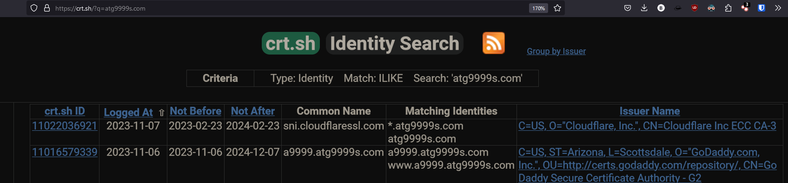
  + <https://a9999.atg9999s.com>
    - First domain I visited gave me an access denied screen
    - The website a9999.atg9999s.com may be banning all who connect
    - url changes to <https://a9999.atg9999s.com/WCC2/Home/Login?ReturnUrl=%2fWCC2%2f>
    - TRY SQL injection here
    - My home ip 24.101.113.252  
      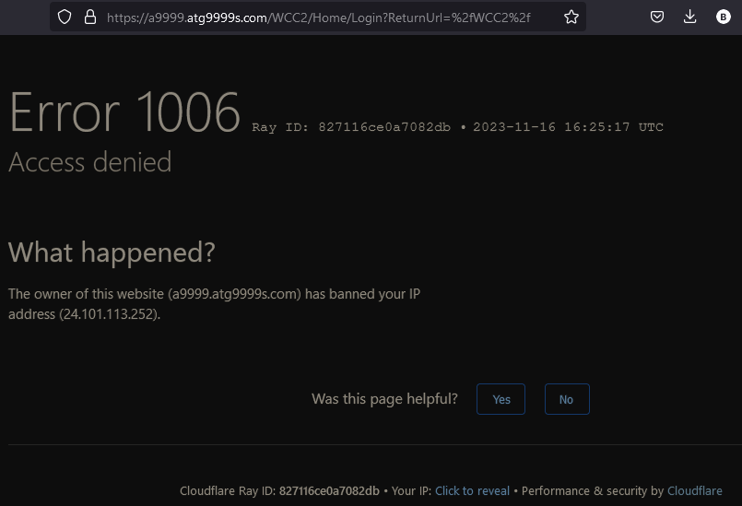
  + <http://a9999.atg9999s.com>
    - An Error 522 means that the request was able to connect to your web server, but that the request didn't finish.
    - 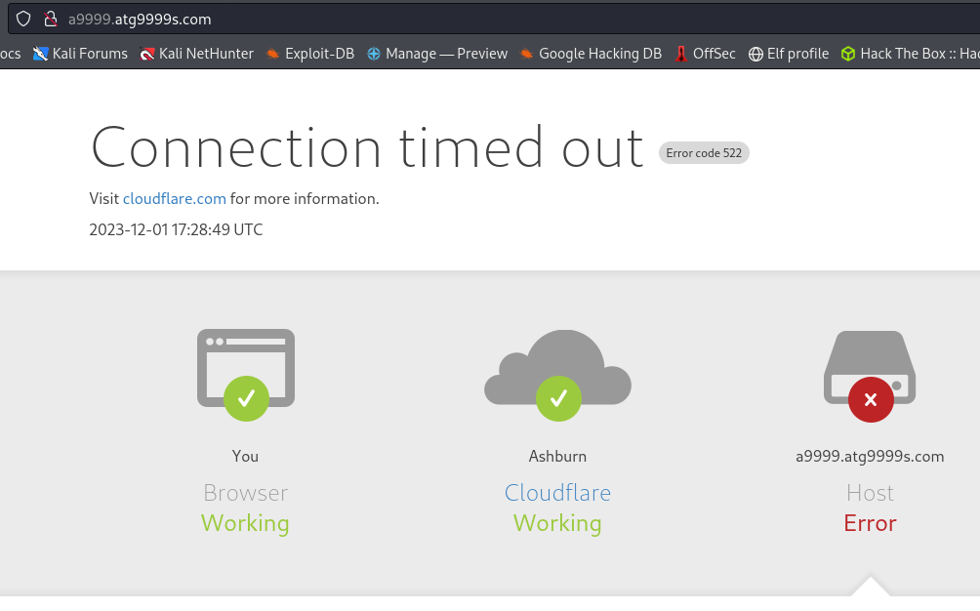
  + [www.a9999.atg9999s.com](http://www.a9999.atg9999s.com)
    - 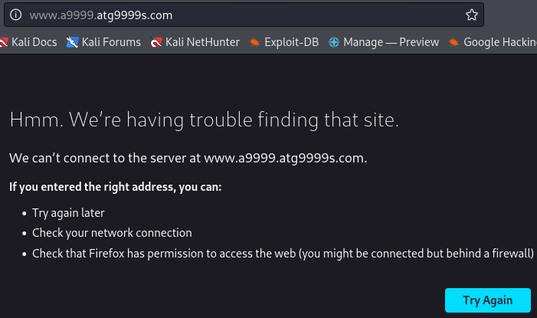
  + *.atg9999s.com
    - does not resolve
  + atg9999s.com
    - Parked by GoDaddy.com
    - 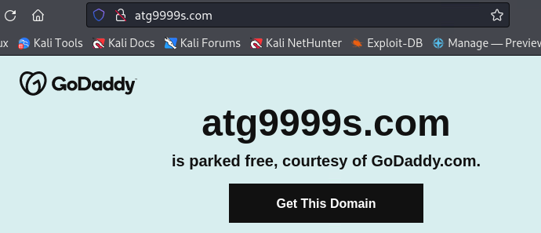
  + web1.atg9999s.com
    - 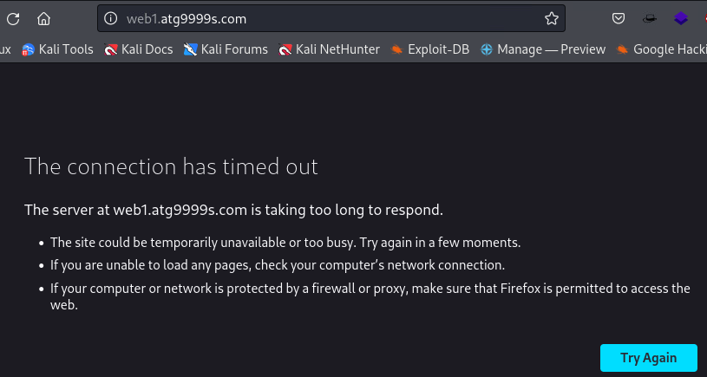
  + <http://www.web1.atg9999s.com> and <https://www.web1.atg9999s.com>
    - does not resolve
    - 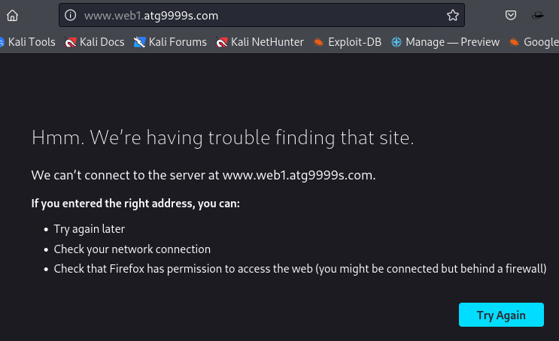
  + <https://web1.atg9999s.com>
    - reveals asp.net home page
    - 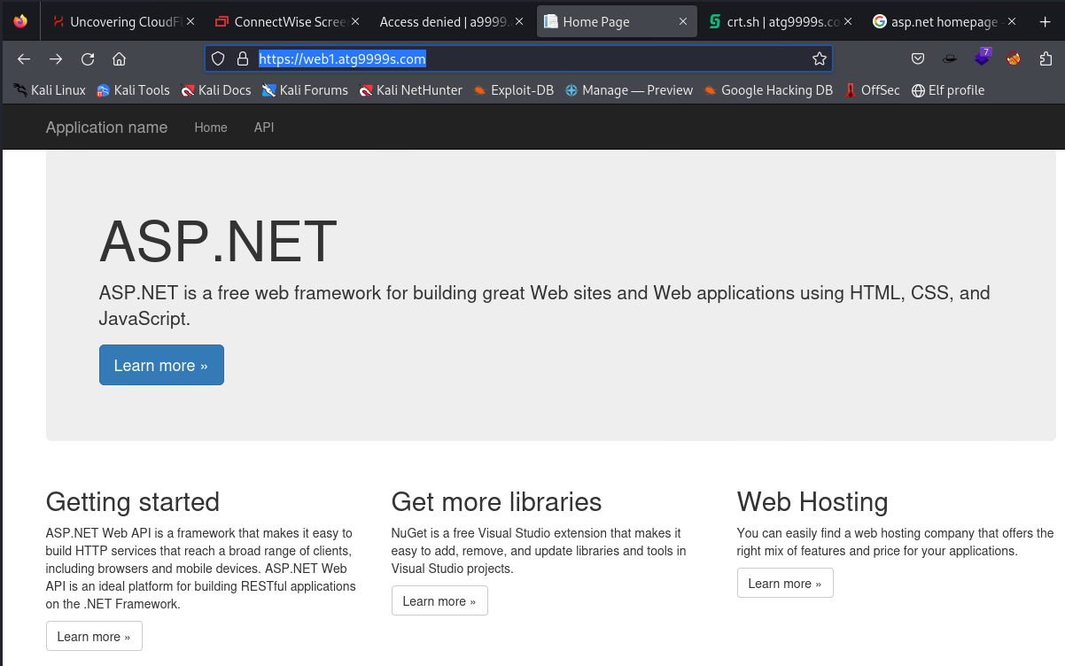
  + <http://c9999.atg9999s.com>
    - 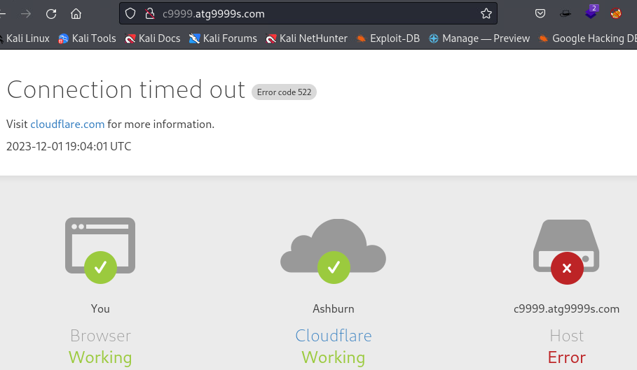
  + <https://c9999.atg9999s.com>
    - Reveals ConnectWise ScreenConnect
    - 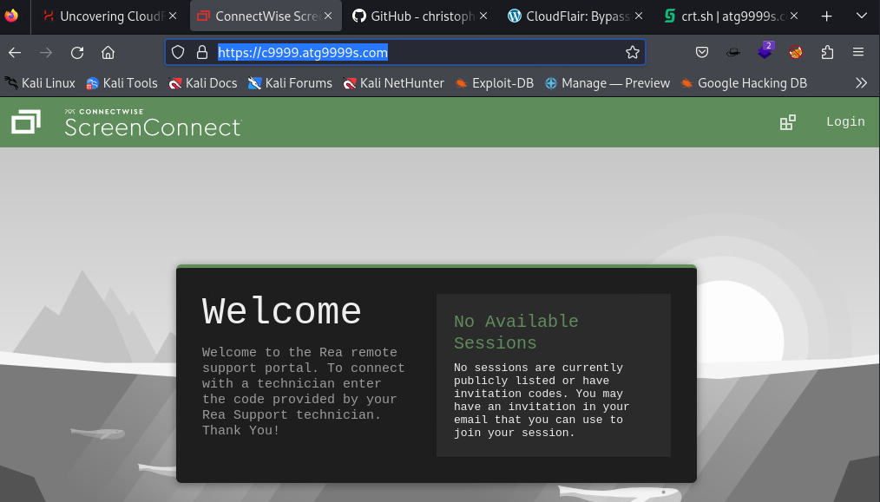
  + [www.c9999.atg9999s.com](http://www.c9999.atg9999s.com)

## Scanning atg9999s.com subdomains with CloudFlair

* CloudFlair <https://github.com/christophetd/CloudFlair>
  + Finds the origin servers of websites protected by CloudFlare (or CloudFront) which are publicly exposed and don't appropriately restrict network access to the relevant CDN IP ranges.
  + Uses Internet-wide scan data from Censys to find exposed IPv4 hosts presenting an SSL certificate associated with the target's domain name.
* Ran CloudFlair on a9999.atg9999s.com and c9999.atg9999s.com - Target
* Copy

┌──(venv)─(kali㉿kali)-[~/CloudFlair]  
└─$ python3 cloudflair.py a9999.atg9999s.com  
[*] Retrieving Cloudflare IP ranges from https://www.cloudflare.com/ips-v4  
[*] The target appears to be behind CloudFlare.  
[*] Looking for certificates matching "a9999.atg9999s.com" using Censys  
[*] 3 certificates matching "a9999.atg9999s.com" found.  
[*] Looking for IPv4 hosts presenting these certificates...  
[*] 0 IPv4 hosts presenting a certificate issued to "a9999.atg9999s.com" were found.  
[-] The target is most likely not vulnerable.  
  
┌──(venv)─(kali㉿kali)-[~/CloudFlair]  
└─$ python3 cloudflair.py c9999.atg9999s.com  
[*] Retrieving Cloudflare IP ranges from https://www.cloudflare.com/ips-v4  
[*] The target appears to be behind CloudFlare.  
[*] Looking for certificates matching "c9999.atg9999s.com" using Censys  
[*] 4 certificates matching "c9999.atg9999s.com" found.  
[*] Looking for IPv4 hosts presenting these certificates...  
[*] 0 IPv4 hosts presenting a certificate issued to "c9999.atg9999s.com" were found.  
[-] The target is most likely not vulnerable.  
Copy

* navigating to the TLD <http://atg9999s.com> and godaddy advertises that the domain is parked free
  + Parked for free means that the owner of the domain name hasn’t developed a site yet and temporarily he uses his domain registrar’s (ex. Godaddy) nameservers. Registrars usually promote their services on parked domains or they show ads.
* clicking through godaddy link reveals that the domain is not available. But could be?  
  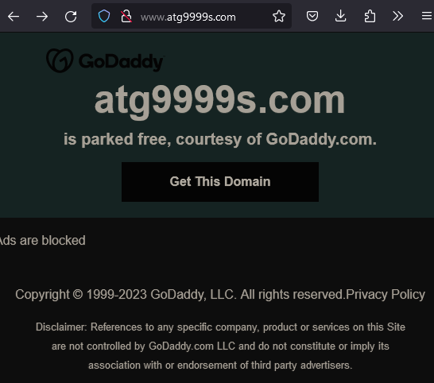

## 34.102.136.180 scans

* **PING**

┌──(kali㉿kali)-[~]  
└─$ ping atg9999s.com   
PING atg9999s.com (34.102.136.180) 56(84) bytes of data.  
64 bytes from 180.136.102.34.bc.googleusercontent.com (34.102.136.180): icmp_seq=1 ttl=117 time=21.3 ms  
64 bytes from 180.136.102.34.bc.googleusercontent.com (34.102.136.180): icmp_seq=2 ttl=117 time=20.0 ms  
64 bytes from 180.136.102.34.bc.googleusercontent.com (34.102.136.180): icmp_seq=3 ttl=117 time=22.6 ms  
64 bytes from 180.136.102.34.bc.googleusercontent.com (34.102.136.180): icmp_seq=4 ttl=117 time=16.6 ms  
64 bytes from 180.136.102.34.bc.googleusercontent.com (34.102.136.180): icmp_seq=5 ttl=117 time=14.7 ms  
64 bytes from 180.136.102.34.bc.googleusercontent.com (34.102.136.180): icmp_seq=6 ttl=117 time=23.5 ms  
^C  
--- atg9999s.com ping statistics ---  
6 packets transmitted, 6 received, 0% packet loss, time 9103ms  
rtt min/avg/max/mdev = 14.692/19.766/23.485/3.167 ms  
Copy

* **NMAP**
* Need to run nmap to scan the ip but I'm concerned about being detected
* modifying my normal nmap scan down to avoid detection
* I couldn't remember the top 100 most common ports and discovered port 100 filtered with newacct service running on it.

┌──(root💀RCS-Response1)-[~]   
└─# nmap -p100 -T2 -v -Pn 34.102.136.180   
Host discovery disabled (-Pn). All addresses will be marked 'up' and scan times will be slower.   
Starting Nmap 7.91 ( https://nmap.org ) at 2023-11-18 12:48 EST   
Initiating Parallel DNS resolution of 1 host. at 12:48   
Completed Parallel DNS resolution of 1 host. at 12:48, 0.09s elapsed   
Initiating SYN Stealth Scan at 12:48   
Scanning 180.136.102.34.bc.googleusercontent.com (34.102.136.180) [1 port]   
Completed SYN Stealth Scan at 12:48, 2.41s elapsed (1 total ports)   
Nmap scan report for 180.136.102.34.bc.googleusercontent.com (34.102.136.180)   
Host is up.   
  
PORT STATE SERVICE   
100/tcp filtered newacct   
  
Read data files from: /usr/bin/../share/nmap   
Nmap done: 1 IP address (1 host up) scanned in 2.68 seconds   
 Raw packets sent: 2 (88B) | Rcvd: 0 (0B)   
   
Copy

* -F top 100 most common ports scan reveals 80 and 443 open

┌──(root💀RCS-Response1)-[~]   
└─# nmap -F -T2 -v -Pn 34.102.136.180   
Host discovery disabled (-Pn). All addresses will be marked 'up' and scan times will be slower.   
Starting Nmap 7.91 ( https://nmap.org ) at 2023-11-18 12:49 EST   
Initiating Parallel DNS resolution of 1 host. at 12:49   
Completed Parallel DNS resolution of 1 host. at 12:49, 0.02s elapsed   
Initiating SYN Stealth Scan at 12:49   
Scanning 180.136.102.34.bc.googleusercontent.com (34.102.136.180) [100 ports]   
Discovered open port 80/tcp on 34.102.136.180   
Discovered open port 443/tcp on 34.102.136.180   
SYN Stealth Scan Timing: About 26.50% done; ETC: 12:51 (0:01:26 remaining)   
SYN Stealth Scan Timing: About 60.50% done; ETC: 12:51 (0:00:40 remaining)   
Completed SYN Stealth Scan at 12:51, 98.23s elapsed (100 total ports)   
Nmap scan report for 180.136.102.34.bc.googleusercontent.com (34.102.136.180)   
Host is up (0.089s latency).   
Not shown: 98 filtered ports   
PORT STATE SERVICE   
80/tcp open http   
443/tcp open https   
  
Read data files from: /usr/bin/../share/nmap   
Nmap done: 1 IP address (1 host up) scanned in 98.38 seconds   
 Raw packets sent: 217 (9.548KB) | Rcvd: 20 (880B)   
   
Copy

* I also ran a long slow scan over the weekend to attempt to avoid detection.

┌──(root💀RCS-Response1)-[~]   
└─# nmap -p- -T2 -v -Pn 34.102.136.180   
Host discovery disabled (-Pn). All addresses will be marked 'up' and scan times will be slower.   
Starting Nmap 7.91 ( https://nmap.org ) at 2023-11-18 14:20 EST   
Initiating Parallel DNS resolution of 1 host. at 14:20   
Completed Parallel DNS resolution of 1 host. at 14:20, 0.09s elapsed   
Initiating SYN Stealth Scan at 14:20   
Scanning 180.136.102.34.bc.googleusercontent.com (34.102.136.180) [65535 ports]   
Discovered open port 443/tcp on 34.102.136.180   
Discovered open port 80/tcp on 34.102.136.180   
Increasing send delay for 34.102.136.180 from 400 to 800 due to 13 out of 43 dropped probes since last increase.   
SYN Stealth Scan Timing: About 0.30% done   
SYN Stealth Scan Timing: About 0.32% done   
SYN Stealth Scan Timing: About 0.33% done   
SYN Stealth Scan Timing: About 0.34% done   
SYN Stealth Scan Timing: About 0.35% done   
SYN Stealth Scan Timing: About 0.36% done   
SYN Stealth Scan Timing: About 0.38% done   
SYN Stealth Scan Timing: About 0.39% done   
SYN Stealth Scan Timing: About 0.41% done   
SYN Stealth Scan Timing: About 0.42% done   
SYN Stealth Scan Timing: About 0.44% done   
SYN Stealth Scan Timing: About 0.45% done   
SYN Stealth Scan Timing: About 0.48% done   
SYN Stealth Scan Timing: About 0.49% done   
SYN Stealth Scan Timing: About 0.51% done   
SYN Stealth Scan Timing: About 0.53% done   
SYN Stealth Scan Timing: About 0.56% done   
SYN Stealth Scan Timing: About 0.58% done   
SYN Stealth Scan Timing: About 0.61% done   
SYN Stealth Scan Timing: About 0.64% done   
SYN Stealth Scan Timing: About 0.66% done   
SYN Stealth Scan Timing: About 0.68% done   
SYN Stealth Scan Timing: About 0.71% done   
SYN Stealth Scan Timing: About 0.73% done   
SYN Stealth Scan Timing: About 0.76% done   
SYN Stealth Scan Timing: About 0.78% done   
SYN Stealth Scan Timing: About 0.81% done   
SYN Stealth Scan Timing: About 0.83% done   
SYN Stealth Scan Timing: About 0.86% done   
SYN Stealth Scan Timing: About 0.89% done   
SYN Stealth Scan Timing: About 0.91% done   
SYN Stealth Scan Timing: About 0.94% done   
SYN Stealth Scan Timing: About 0.96% done   
SYN Stealth Scan Timing: About 0.99% done   
SYN Stealth Scan Timing: About 1.01% done; ETC: 05:04 (38:20:32 remaining)   
SYN Stealth Scan Timing: About 1.41% done; ETC: 03:16 (36:23:54 remaining)   
SYN Stealth Scan Timing: About 2.80% done; ETC: 01:53 (34:32:59 remaining)   
SYN Stealth Scan Timing: About 4.47% done; ETC: 00:39 (32:46:08 remaining)   
Stats: 2:21:06 elapsed; 0 hosts completed (1 up), 1 undergoing SYN Stealth Scan   
SYN Stealth Scan Timing: About 7.02% done; ETC: 23:52 (31:10:12 remaining)   
SYN Stealth Scan Timing: About 11.28% done; ETC: 23:35 (29:29:38 remaining)   
SYN Stealth Scan Timing: About 16.53% done; ETC: 23:41 (27:49:52 remaining)   
SYN Stealth Scan Timing: About 21.01% done; ETC: 23:28 (26:09:44 remaining)   
SYN Stealth Scan Timing: About 26.12% done; ETC: 23:31 (24:30:22 remaining)   
adjust_timeouts2: packet supposedly had rtt of 8448282 microseconds. Ignoring time.   
adjust_timeouts2: packet supposedly had rtt of 8448282 microseconds. Ignoring time.   
SYN Stealth Scan Timing: About 30.88% done; ETC: 23:24 (22:50:51 remaining)   
SYN Stealth Scan Timing: About 35.86% done; ETC: 23:23 (21:11:37 remaining)   
SYN Stealth Scan Timing: About 40.78% done; ETC: 23:20 (19:32:28 remaining)   
SYN Stealth Scan Timing: About 45.63% done; ETC: 23:15 (17:53:28 remaining)   
SYN Stealth Scan Timing: About 50.52% done; ETC: 23:10 (16:14:43 remaining)   
SYN Stealth Scan Timing: About 55.44% done; ETC: 23:06 (14:36:13 remaining)   
SYN Stealth Scan Timing: About 60.41% done; ETC: 23:05 (12:57:52 remaining)   
SYN Stealth Scan Timing: About 65.37% done; ETC: 23:03 (11:19:35 remaining)   
SYN Stealth Scan Timing: About 70.34% done; ETC: 23:01 (9:41:24 remaining)   
SYN Stealth Scan Timing: About 75.32% done; ETC: 22:58 (8:03:21 remaining)   
SYN Stealth Scan Timing: About 80.31% done; ETC: 22:58 (6:25:25 remaining)   
SYN Stealth Scan Timing: About 85.32% done; ETC: 22:59 (4:47:31 remaining)   
SYN Stealth Scan Timing: About 90.32% done; ETC: 22:58 (3:09:34 remaining)   
SYN Stealth Scan Timing: About 95.32% done; ETC: 22:58 (1:31:38 remaining)   
Completed SYN Stealth Scan at 22:57, 117409.93s elapsed (65535 total ports)   
Nmap scan report for 180.136.102.34.bc.googleusercontent.com (34.102.136.180)   
Host is up (0.052s latency).   
Not shown: 65533 filtered ports   
PORT STATE SERVICE   
80/tcp open http   
443/tcp open https   
  
Read data files from: /usr/bin/../share/nmap   
Nmap done: 1 IP address (1 host up) scanned in 117410.13 seconds   
 Raw packets sent: 144174 (6.344MB) | Rcvd: 13143 (578.292KB)   
Copy

* Another nmap scan to detect versions running on open ports.
* 80 openresty and 443 tcpwrapped but could not detect versions
* robots.txt exists

┌──(kali㉿kali)-[~]  
└─$ nmap -p 80,443 -A 34.102.136.180  
Starting Nmap 7.94 ( https://nmap.org ) at 2023-11-20 07:09 EST  
Stats: 0:00:28 elapsed; 0 hosts completed (1 up), 1 undergoing Service Scan  
Service scan Timing: About 50.00% done; ETC: 07:10 (0:00:28 remaining)  
Stats: 0:00:43 elapsed; 0 hosts completed (1 up), 1 undergoing Service Scan  
Service scan Timing: About 50.00% done; ETC: 07:11 (0:00:43 remaining)  
Nmap scan report for 180.136.102.34.bc.googleusercontent.com (34.102.136.180)  
Host is up (0.022s latency).  
  
PORT STATE SERVICE VERSION  
80/tcp open http openresty  
| http-robots.txt: 1 disallowed entry   
|_/  
|_http-server-header: openresty  
|_http-title: Site doesn't have a title (text/html).  
| fingerprint-strings:   
| FourOhFourRequest:   
| HTTP/1.0 403 Forbidden  
| Server: openresty  
| Date: Mon, 20 Nov 2023 16:58:03 GMT  
| Content-Type: text/html  
| Content-Length: 291  
| ETag: "6552adee-123"  
| Via: 1.1 google  
| <!DOCTYPE html>  
| <html lang="en">  
| <head>  
| <meta http-equiv="content-type" content="text/html;charset=utf-8" />  
| <link rel="shortcut icon" href="data:image/x-icon;," type="image/x-icon" />  
| <title>Forbidden</title>  
| </head>  
| <body>  
| <h1>Access Forbidden</h1>  
| </body>  
| </html>  
| GetRequest:   
| HTTP/1.0 403 Forbidden  
| Server: openresty  
| Date: Mon, 20 Nov 2023 16:57:58 GMT  
| Content-Type: text/html  
| Content-Length: 291  
| ETag: "6552adee-123"  
| Via: 1.1 google  
| <!DOCTYPE html>  
| <html lang="en">  
| <head>  
| <meta http-equiv="content-type" content="text/html;charset=utf-8" />  
| <link rel="shortcut icon" href="data:image/x-icon;," type="image/x-icon" />  
| <title>Forbidden</title>  
| </head>  
| <body>  
| <h1>Access Forbidden</h1>  
| </body>  
| </html>  
| HTTPOptions:   
| HTTP/1.0 403 Forbidden  
| Server: openresty  
| Date: Mon, 20 Nov 2023 16:57:58 GMT  
| Content-Type: text/html  
| Content-Length: 150  
| Via: 1.1 google  
| <html>  
| <head><title>403 Forbidden</title></head>  
| <body>  
| <center><h1>403 Forbidden</h1></center>  
| <hr><center>openresty</center>  
| </body>  
| </html>  
| RTSPRequest:   
| HTTP/1.0 400 Bad Request  
| Content-Type: text/html; charset=UTF-8  
| Referrer-Policy: no-referrer  
| Content-Length: 273  
| Date: Mon, 20 Nov 2023 16:57:58 GMT  
| <html><head>  
| <meta http-equiv="content-type" content="text/html;charset=utf-8">  
| <title>400 Bad Request</title>  
| </head>  
| <body text=#000000 bgcolor=#ffffff>  
| <h1>Error: Bad Request</h1>  
| <h2>Your client has issued a malformed or illegal request.</h2>  
| <h2></h2>  
|_ </body></html>  
443/tcp open tcpwrapped  
1 service unrecognized despite returning data. If you know the service/version, please submit the following fingerprint at https://nmap.org/cgi-bin/submit.cgi?new-service :  
SF-Port80-TCP:V=7.94%I=7%D=11/20%Time=655B4C8A%P=x86_64-pc-linux-gnu%r(Get  
SF:Request,1CA,"HTTP/1\.0\x20403\x20Forbidden\r\nServer:\x20openresty\r\nD  
SF:ate:\x20Mon,\x2020\x20Nov\x202023\x2016:57:58\x20GMT\r\nContent-Type:\x  
SF:20text/html\r\nContent-Length:\x20291\r\nETag:\x20\"6552adee-123\"\r\nV  
SF:ia:\x201\.1\x20google\r\n\r\n<!DOCTYPE\x20html>\n<html\x20lang=\"en\">\  
SF:n\x20\x20<head>\n\x20\x20\x20\x20<meta\x20http-equiv=\"content-type\"\x  
SF:20content=\"text/html;charset=utf-8\"\x20/>\n\x20\x20\x20\x20<link\x20r  
SF:el=\"shortcut\x20icon\"\x20href=\"data:image/x-icon;,\"\x20type=\"image  
SF:/x-icon\"\x20/>\n\x20\x20\x20\x20<title>Forbidden</title>\n\x20\x20</he  
SF:ad>\n\x20\x20<body>\n\x20\x20\x20\x20<h1>Access\x20Forbidden</h1>\n\x20  
SF:\x20</body>\n</html>\n")%r(HTTPOptions,127,"HTTP/1\.0\x20403\x20Forbidd  
SF:en\r\nServer:\x20openresty\r\nDate:\x20Mon,\x2020\x20Nov\x202023\x2016:  
SF:57:58\x20GMT\r\nContent-Type:\x20text/html\r\nContent-Length:\x20150\r\  
SF:nVia:\x201\.1\x20google\r\n\r\n<html>\r\n<head><title>403\x20Forbidden<  
SF:/title></head>\r\n<body>\r\n<center><h1>403\x20Forbidden</h1></center>\  
SF:r\n<hr><center>openresty</center>\r\n</body>\r\n</html>\r\n")%r(RTSPReq  
SF:uest,1AD,"HTTP/1\.0\x20400\x20Bad\x20Request\r\nContent-Type:\x20text/h  
SF:tml;\x20charset=UTF-8\r\nReferrer-Policy:\x20no-referrer\r\nContent-Len  
SF:gth:\x20273\r\nDate:\x20Mon,\x2020\x20Nov\x202023\x2016:57:58\x20GMT\r\  
SF:n\r\n\n<html><head>\n<meta\x20http-equiv=\"content-type\"\x20content=\"  
SF:text/html;charset=utf-8\">\n<title>400\x20Bad\x20Request</title>\n</hea  
SF:d>\n<body\x20text=#000000\x20bgcolor=#ffffff>\n<h1>Error:\x20Bad\x20Req  
SF:uest</h1>\n<h2>Your\x20client\x20has\x20issued\x20a\x20malformed\x20or\  
SF:x20illegal\x20request\.</h2>\n<h2></h2>\n</body></html>\n")%r(FourOhFou  
SF:rRequest,1CA,"HTTP/1\.0\x20403\x20Forbidden\r\nServer:\x20openresty\r\n  
SF:Date:\x20Mon,\x2020\x20Nov\x202023\x2016:58:03\x20GMT\r\nContent-Type:\  
SF:x20text/html\r\nContent-Length:\x20291\r\nETag:\x20\"6552adee-123\"\r\n  
SF:Via:\x201\.1\x20google\r\n\r\n<!DOCTYPE\x20html>\n<html\x20lang=\"en\">  
SF:\n\x20\x20<head>\n\x20\x20\x20\x20<meta\x20http-equiv=\"content-type\"\  
SF:x20content=\"text/html;charset=utf-8\"\x20/>\n\x20\x20\x20\x20<link\x20  
SF:rel=\"shortcut\x20icon\"\x20href=\"data:image/x-icon;,\"\x20type=\"imag  
SF:e/x-icon\"\x20/>\n\x20\x20\x20\x20<title>Forbidden</title>\n\x20\x20</h  
SF:ead>\n\x20\x20<body>\n\x20\x20\x20\x20<h1>Access\x20Forbidden</h1>\n\x2  
SF:0\x20</body>\n</html>\n");  
Copy

* robots.txt reveals  
  - user-agents - specifies rules for specific web crawlers, Googlebot, Bingbot, Slurp and Baiduspider  
  - Crawl-delay - permitted to crawl with a delay of 10 sec between requests  
  - Disallow: blank no specific paths are disallowed for theses bots  
  - user-agent: * - all others  
  - Disallow: / - not permitted to crawl any part of the site  
  - **Consider** Disallowing all web crawlers to ensure that any bot regardless of it's identity, is barred from accessing any part of the domain.  
  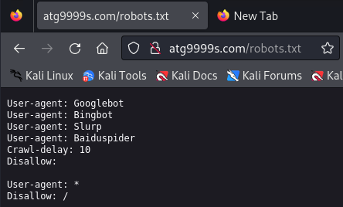
* **MetaSploit and SearchSploit**
* Quick search on metasploit and searchsploit for openresty and tcpwrapped open did not yield any existing vulnerabilities.

┌──(kali㉿kali)-[~]  
└─$ msfconsole  
   
 , ,  
 / \ ((__---,,,---__)) (_) O O (_)_________ \ _ / |\ o_o \ M S F | \ \ _____ | * ||| WW||| ||| |||   
   
  
 =[ metasploit v6.3.31-dev ]  
+ -- --=[ 2346 exploits - 1220 auxiliary - 413 post ]  
+ -- --=[ 1390 payloads - 46 encoders - 11 nops ]  
+ -- --=[ 9 evasion ]  
  
Metasploit tip: Display the Framework log using the   
log command, learn more with help log  
Metasploit Documentation: https://docs.metasploit.com/  
  
msf6 > search openresty  
[-] No results from search  
msf6 > tcpwrapped  
[-] Unknown command: tcpwrapped  
msf6 > search tcpwrapped  
[-] No results from search  
msf6 > exit  
   
┌──(kali㉿kali)-[~]  
└─$ searchsploit openresty   
Exploits: No Results  
Shellcodes: No Results  
Copy

## ping c9999.atg9999s.com

* reveals another ip address 104.26.0.29

┌──(venv)─(kali㉿kali)-[~/CloudFlair]  
└─$ ping c9999.atg9999s.com   
PING c9999.atg9999s.com (104.26.0.29) 56(84) bytes of data.  
64 bytes from 104.26.0.29 (104.26.0.29): icmp_seq=1 ttl=52 time=33.8 ms  
64 bytes from 104.26.0.29 (104.26.0.29): icmp_seq=2 ttl=52 time=26.9 ms  
64 bytes from 104.26.0.29 (104.26.0.29): icmp_seq=3 ttl=52 time=54.1 ms  
^C  
--- c9999.atg9999s.com ping statistics ---  
3 packets transmitted, 3 received, 0% packet loss, time 2003ms  
rtt min/avg/max/mdev = 26.891/38.258/54.101/11.550 ms  
Copy

## whois 104.26.0.29

* reveals CloudFlare

┌──(venv)─(kali㉿kali)-[~/CloudFlair]  
└─$ whois 104.26.0.29   
  
#  
# ARIN WHOIS data and services are subject to the Terms of Use  
# available at: https://www.arin.net/resources/registry/whois/tou/  
#  
# If you see inaccuracies in the results, please report at  
# https://www.arin.net/resources/registry/whois/inaccuracy_reporting/  
#  
# Copyright 1997-2023, American Registry for Internet Numbers, Ltd.  
#  
  
  
NetRange: 104.16.0.0 - 104.31.255.255  
CIDR: 104.16.0.0/12  
NetName: CLOUDFLARENET  
NetHandle: NET-104-16-0-0-1  
Parent: NET104 (NET-104-0-0-0-0)  
NetType: Direct Allocation  
OriginAS: AS13335  
Organization: Cloudflare, Inc. (CLOUD14)  
RegDate: 2014-03-28  
Updated: 2021-05-26  
Comment: All Cloudflare abuse reporting can be done via https://www.cloudflare.com/abuse  
Ref: https://rdap.arin.net/registry/ip/104.16.0.0  
  
  
OrgName: Cloudflare, Inc.  
OrgId: CLOUD14  
Address: 101 Townsend Street  
City: San Francisco  
StateProv: CA  
PostalCode: 94107  
Country: US  
RegDate: 2010-07-09  
Updated: 2021-07-01  
Ref: https://rdap.arin.net/registry/entity/CLOUD14  
  
  
OrgAbuseHandle: ABUSE2916-ARIN  
OrgAbuseName: Abuse  
OrgAbusePhone: +1-650-319-8930   
OrgAbuseEmail: abuse@cloudflare.com  
OrgAbuseRef: https://rdap.arin.net/registry/entity/ABUSE2916-ARIN  
  
OrgTechHandle: ADMIN2521-ARIN  
OrgTechName: Admin  
OrgTechPhone: +1-650-319-8930   
OrgTechEmail: rir@cloudflare.com  
OrgTechRef: https://rdap.arin.net/registry/entity/ADMIN2521-ARIN  
  
OrgNOCHandle: CLOUD146-ARIN  
OrgNOCName: Cloudflare-NOC  
OrgNOCPhone: +1-650-319-8930   
OrgNOCEmail: noc@cloudflare.com  
OrgNOCRef: https://rdap.arin.net/registry/entity/CLOUD146-ARIN  
  
OrgRoutingHandle: CLOUD146-ARIN  
OrgRoutingName: Cloudflare-NOC  
OrgRoutingPhone: +1-650-319-8930   
OrgRoutingEmail: noc@cloudflare.com  
OrgRoutingRef: https://rdap.arin.net/registry/entity/CLOUD146-ARIN  
  
RTechHandle: ADMIN2521-ARIN  
RTechName: Admin  
RTechPhone: +1-650-319-8930   
RTechEmail: rir@cloudflare.com  
RTechRef: https://rdap.arin.net/registry/entity/ADMIN2521-ARIN  
  
RNOCHandle: NOC11962-ARIN  
RNOCName: NOC  
RNOCPhone: +1-650-319-8930   
RNOCEmail: noc@cloudflare.com  
RNOCRef: https://rdap.arin.net/registry/entity/NOC11962-ARIN  
  
RAbuseHandle: ABUSE2916-ARIN  
RAbuseName: Abuse  
RAbusePhone: +1-650-319-8930   
RAbuseEmail: abuse@cloudflare.com  
RAbuseRef: https://rdap.arin.net/registry/entity/ABUSE2916-ARIN  
  
  
#  
# ARIN WHOIS data and services are subject to the Terms of Use  
# available at: https://www.arin.net/resources/registry/whois/tou/  
#  
# If you see inaccuracies in the results, please report at  
# https://www.arin.net/resources/registry/whois/inaccuracy_reporting/  
#  
# Copyright 1997-2023, American Registry for Internet Numbers, Ltd.  
Copy

## NMAP 104.26.0.29

* open ports

┌──(venv)─(kali㉿kali)-[~/CloudFlair]  
└─$ nmap -p- -T4 -vv -Pn 104.26.0.29  
Host discovery disabled (-Pn). All addresses will be marked 'up' and scan times may be slower.  
Starting Nmap 7.94SVN ( https://nmap.org ) at 2023-12-05 00:45 EST  
Initiating Parallel DNS resolution of 1 host. at 00:45  
Completed Parallel DNS resolution of 1 host. at 00:45, 0.03s elapsed  
Initiating Connect Scan at 00:45  
Scanning 104.26.0.29 [65535 ports]  
Discovered open port 8080/tcp on 104.26.0.29  
Discovered open port 443/tcp on 104.26.0.29  
Discovered open port 80/tcp on 104.26.0.29  
Stats: 0:00:09 elapsed; 0 hosts completed (1 up), 1 undergoing Connect Scan  
Connect Scan Timing: About 2.95% done; ETC: 00:50 (0:04:56 remaining)  
Connect Scan Timing: About 13.03% done; ETC: 00:50 (0:04:20 remaining)  
Connect Scan Timing: About 23.49% done; ETC: 00:50 (0:04:04 remaining)  
Discovered open port 2096/tcp on 104.26.0.29  
Connect Scan Timing: About 23.00% done; ETC: 00:52 (0:05:51 remaining)  
Connect Scan Timing: About 29.83% done; ETC: 00:52 (0:05:18 remaining)  
Connect Scan Timing: About 36.00% done; ETC: 00:52 (0:04:53 remaining)  
Connect Scan Timing: About 43.07% done; ETC: 00:52 (0:04:18 remaining)  
Discovered open port 2052/tcp on 104.26.0.29  
Discovered open port 2082/tcp on 104.26.0.29  
Connect Scan Timing: About 50.54% done; ETC: 00:52 (0:03:40 remaining)  
Connect Scan Timing: About 57.53% done; ETC: 00:52 (0:03:08 remaining)  
Discovered open port 8443/tcp on 104.26.0.29  
Connect Scan Timing: About 64.26% done; ETC: 00:52 (0:02:39 remaining)  
Connect Scan Timing: About 71.11% done; ETC: 00:52 (0:02:08 remaining)  
Discovered open port 8880/tcp on 104.26.0.29  
Connect Scan Timing: About 58.59% done; ETC: 00:54 (0:04:04 remaining)  
Discovered open port 2095/tcp on 104.26.0.29  
Connect Scan Timing: About 50.56% done; ETC: 00:57 (0:06:07 remaining)  
Discovered open port 2086/tcp on 104.26.0.29  
Connect Scan Timing: About 45.66% done; ETC: 00:59 (0:08:02 remaining)  
Connect Scan Timing: About 50.58% done; ETC: 00:59 (0:07:14 remaining)  
Connect Scan Timing: About 55.70% done; ETC: 00:59 (0:06:27 remaining)  
Connect Scan Timing: About 60.97% done; ETC: 00:59 (0:05:42 remaining)  
Connect Scan Timing: About 66.11% done; ETC: 00:59 (0:04:57 remaining)  
Connect Scan Timing: About 71.51% done; ETC: 00:59 (0:04:10 remaining)  
Discovered open port 2087/tcp on 104.26.0.29  
Connect Scan Timing: About 76.90% done; ETC: 00:59 (0:03:23 remaining)  
Connect Scan Timing: About 82.08% done; ETC: 00:59 (0:02:38 remaining)  
Discovered open port 2083/tcp on 104.26.0.29  
Connect Scan Timing: About 87.24% done; ETC: 00:59 (0:01:53 remaining)  
Discovered open port 2053/tcp on 104.26.0.29  
Connect Scan Timing: About 92.39% done; ETC: 00:59 (0:01:07 remaining)  
Completed Connect Scan at 00:59, 881.11s elapsed (65535 total ports)  
Nmap scan report for 104.26.0.29  
Host is up, received user-set (0.047s latency).  
Scanned at 2023-12-05 00:45:06 EST for 881s  
Not shown: 65522 filtered tcp ports (no-response)  
PORT STATE SERVICE REASON  
80/tcp open http syn-ack  
443/tcp open https syn-ack  
2052/tcp open clearvisn syn-ack  
2053/tcp open knetd syn-ack  
2082/tcp open infowave syn-ack  
2083/tcp open radsec syn-ack  
2086/tcp open gnunet syn-ack  
2087/tcp open eli syn-ack  
2095/tcp open nbx-ser syn-ack  
2096/tcp open nbx-dir syn-ack  
8080/tcp open http-proxy syn-ack  
8443/tcp open https-alt syn-ack  
8880/tcp open cddbp-alt syn-ack  
  
Read data files from: /usr/bin/../share/nmap  
Nmap done: 1 IP address (1 host up) scanned in 881.22 seconds  
Copy

## ping web1.atg9999s.com

* reveals another ip address 13.82.191.84
* but not response

┌──(venv)─(kali㉿kali)-[~/CloudFlair]  
└─$ ping web1.atg9999s.com  
PING web1.atg9999s.com (13.82.191.84) 56(84) bytes of data.  
^C  
--- web1.atg9999s.com ping statistics ---  
8 packets transmitted, 0 received, 100% packet loss, time 7169ms  
Copy